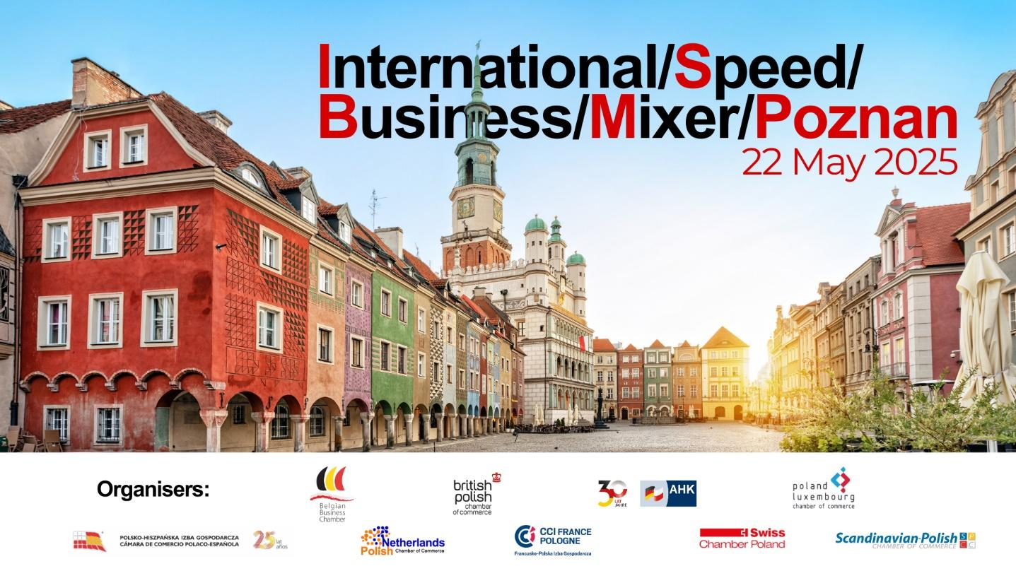

Regulations of the International Speed Business Meeting on 22.05.2025
Conference Center Młyńska 12, ul. Młyńska 12, Poznań
- Only one person from each company interested in the meeting can take part. The second part of the meeting - the Business Mixer - can be attended by a second additional person from the company.
- On the day of the meeting, upon arrival, each participant will receive an individual interview schedule. The organizers do not guarantee a meeting with companies from the industry the participant has marked on the application form.
- Participants will be divided into groups of up to 10 people. In each group, the respective participant will introduce himself/herself to the other members of the group in an approximately 2-minute speech. After about 20 minutes and the exchange of business cards with the participants of the respective group, each participant will move on to the next group, according to the individual schedule presented at the beginning. The number of groups in which a participant will be able to present his/her own company will depend on the number of applications.
- The interviewees will be divided into groups established on the basis of the completed application form. However, the organizers do not guarantee a meeting with the companies from each of the sectors the participant has marked on the form.
- Interviews will be conducted in Polish and/or English.
- The participation fee for the meeting is 250.00 PLN net for member companies of the organizing chambers.
- Due to the limited number of spots, individuals from companies affiliated with the Belgian Business Chamber who confirm their attendance but do not participate and fail to cancel by 15 May 2025, will be invoiced 250.00 PLN net for attending the meeting. For individuals from non-affiliated companies, the fee will be 450 PLN net for attending the meeting.
- The participation fee for companies not affiliated with Belgian Business Chamber is 450.00 PLN net.
- Interested individuals are kindly requested to complete the registration form by 15 May 2025.

Agenda:
17.30 – 18.00 Registration
18.00 - 18.30 Welcoming
18.30 – 19.30 Speed Business Meetings
19.30 – 21.00 Networking

***
Participation in the meeting for companies affiliated with the Belgian Business Chamber is charged at 250 PLN + VAT.
The cost for non-member companies is 450 PLN + VAT.
***
Please note that only one representative from each company can attend the Speed Business Mixer.
Other company representatives can join the Networking Business Drink.
***
Please register by 15 May at the latest by completing the ONLINE FORM.
***
Please be advised: registration is binding. If you do not cancel by 15 May 2025, and fail to attend the meeting, you will be invoiced 250 PLN net for member companies / 450 PLN net for non-member companies.
***

