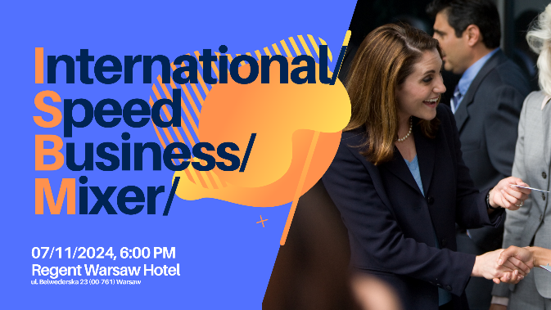

Regulations of the International Speed Business Meeting on 6.11.2025
Regent Warsaw Hotel, ul. Belwederska 23 (00-761), Warsaw
- Only one person from each company interested in the meeting can take part. The second part of the meeting - the Business Mixer - can be attended by a second additional person from the company.
- On the day of the meeting, upon arrival, each participant will receive an individual interview schedule. The organizers do not guarantee a meeting with companies from the industry the participant has marked on the application form.
- Participants will be divided into groups of up to 10 people. In each group, the respective participant will introduce himself/herself to the other members of the group in an approximately 2-minute speech. After about 20 minutes and the exchange of business cards with the participants of the respective group, each participant will move on to the next group, according to the individual schedule presented at the beginning. The number of groups in which a participant will be able to present his/her own company will depend on the number of applications.
- The interviewees will be divided into groups established on the basis of the completed application form. However, the organizers do not guarantee a meeting with the companies from each of the sectors the participant has marked on the form.
- Interviews will be conducted in Polish and/or English.
- The cost of participation in the meeting is 300 PLN net. for member companies of the organizers' chambers.
- Due to the limited number of places, persons from companies associated in Belgian Business Chamber who confirm their attendance but do not participate and do not cancel their participation by 2.11.2025 will be invoiced for 300.00 PLN net for participation in the meeting, persons from non-associated companies - 500 PLN net for participation in the meeting.
- The cost of participation for companies not associated in Belgian Business Chamber is 500.00 PLN net.
- Persons interested in participation, please complete the registration form by 2.11.2025.

Agenda:
17.30 – 18.00 Registration
18.00 - 19.30 Welcoming and Speed Business Mixer
19.30 – 21.00 Networking Business Drink

***
Participation in the meeting for companies affiliated to Belgian Business Chamber is 300 PLN + VAT.
The cost for non-member companies is 500 PLN + VAT.
***
Please note that we can only accept 1 representative from each company at the Speed Business Mixer.
Other company representatives can join the Networking Business Drink.
***
Please register by 2nd November 2025 at the latest by completing the ONLINE FORM.
***
Please be advised: registration is binding. If you do not cancel by 2nd November 2025 and do not attend
to the meeting, you will receive an invoice of PLN 300 net (members Belgian Business Chamber),
PLN 500 net (non-members Belgian Business Chamber).

***

